

12 PHYSICS

MOTION & FORCES
VECTORS IN TWO DIMENSIONS

Vectors have a size and direction that must be specified at all times.
e.g. displacement, velocity, acceleration, force, momentum, impulse, etc.

Scalars have size only - no direction is necessary.
e.g. distance, speed, work, energy, power, etc.

If two vectors are acting at the same point, it is easiest to use the parallelogram method to add them.

Note

Even if the vectors don’t act at the same point, this method proves to be the best for solving problems.

The “rules” for using this method are simple.

1. Draw in a set of “cross-hairs” (with compass directions if appropriate).

2. Draw the two vectors originating at the centre. Make their size roughly to scale.

3. Construct the other two sides of the parallelogram.

4. Rule in the resultant vector, which is the diagonal starting at the centre.

5. Of the two triangles formed, choose the one with an obviously acute angle near the centre of the cross-hairs.

Examples

1. Plane Flying

A plane flying at 7.20 x 10² kmh⁻¹ N30.0°E has to contend with a wind of 1.20 x 10² kmh⁻¹
from the east. Determine the resultant velocity of the plane over the ground.

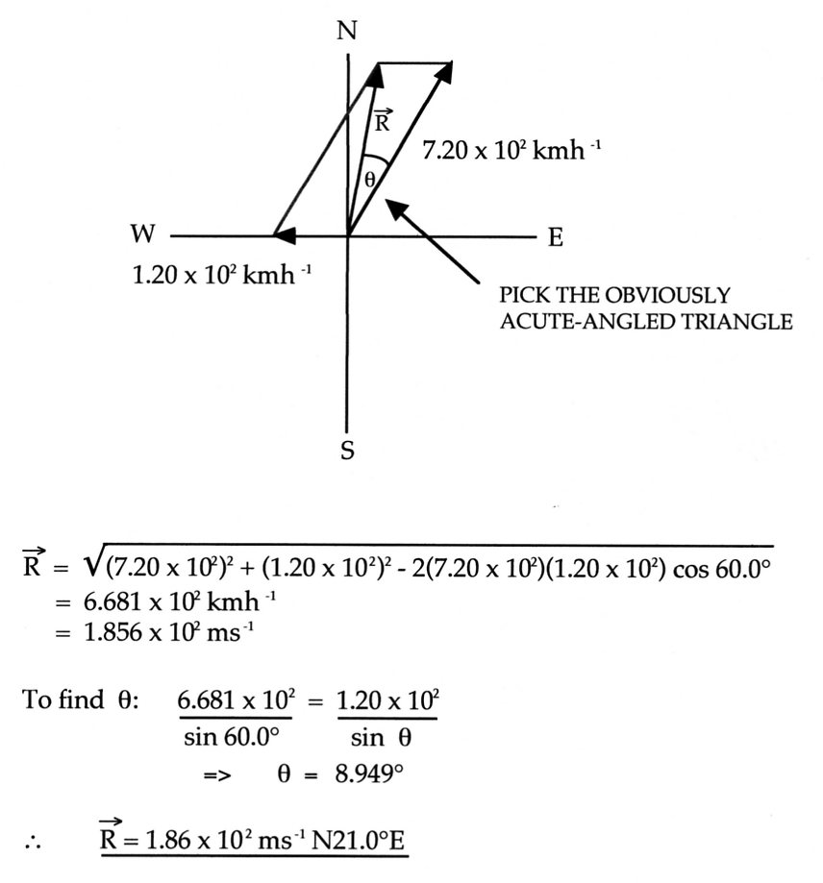

2. Change In Velocity

This is an example of subtraction of vectors since ∆v = v-u.

The basic rule is:

“When subtracting a vector, change its direction 180° and add it to the other
vector”.

A car travelling at 30.0 kmh⁻¹ due west turns left and moves at 25.0 kmh⁻¹. Calculate the
change in velocity of the car.

3.
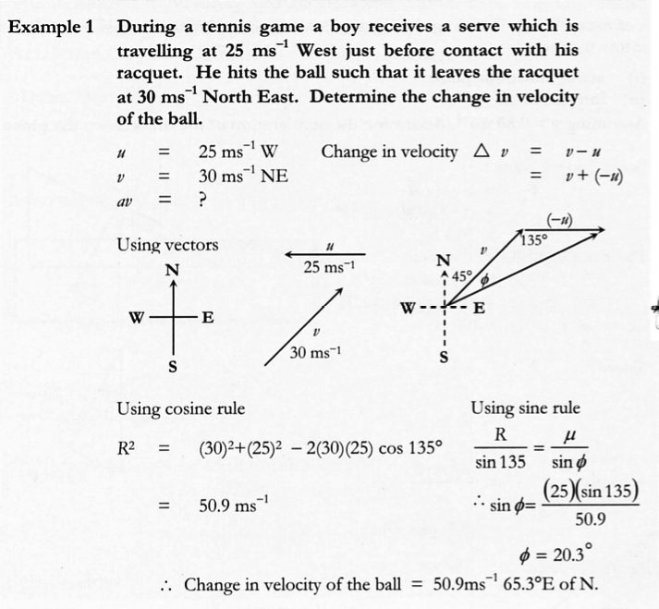

COMPONENTS OF A VECTOR

Any single vector can be expressed as two component vectors that are at right angles to each other.

Neither component vector can be bigger than the original vector.

Any component is given by:

where R = given vector.
θ = the angle between R and the direction of the required component.

Examples

1. Inclined Plane

A box weighing 80.0 N sits at rest on a plane inclined at 27.0° to the horizontal.

(a) Draw a diagram showing all forces acting on the box.
(b) Calculate the force exerted perpendicular to the plane by the box onto the plane.

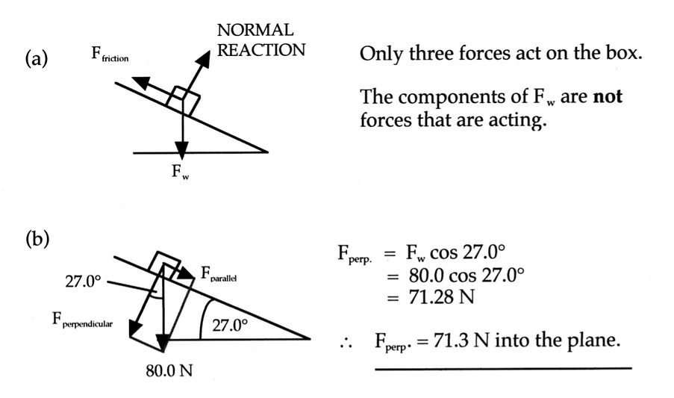
2.
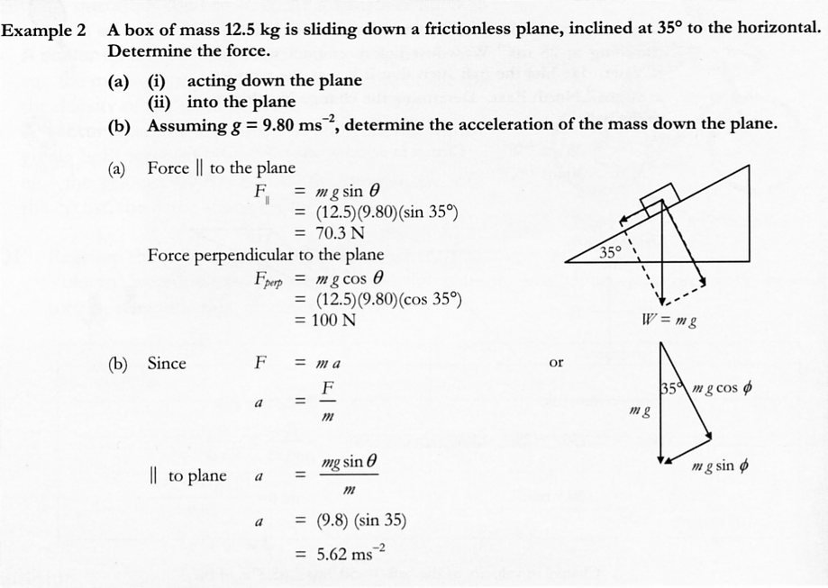
3. Consider the forces acting on a smooth incline (no friction) and one with friction.

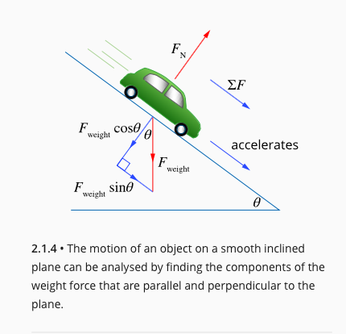
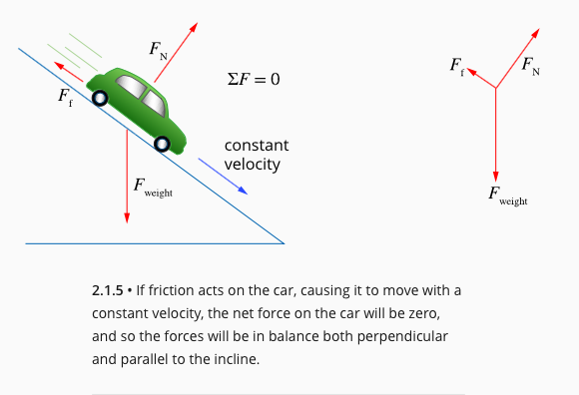

4. River Problem

A person wants to cross a river 8.00 x 10² m wide to reach a jetty directly across on the
opposite bank. If the river is flowing at 6.00 ms⁻¹ and the boat that is used can travel at
15.0 ms⁻¹ in still water, calculate:

(a) the resultant velocity of the boat in relation to the river bottom (or bank).
(b) the time taken to reach the other side.

5. If the person in Question 3 was trying to reach a jetty 2.00 x 10² m upstream, calculate the resultant velocity and the time taken.

ADDING MORE THAN TWO VECTORS

The best way to solve these problems is to use components to reduce the problem to the addition of two vectors at right angles to each other.

Generally this will be done by considering movement in two dimensions within a plane.
i.e. up / down /left / right
north /south / east / west (if compass directions are given).

Example

A heavy crate is being lifted by two cables as shown below.

If the crate weighs 2.00 x 10⁴ N and the tension in each cable is as shown, calculate the
resultant force experienced by the crate.

EQUATIONS OF MOTION

From Year 11, the equations of motion are:

These equations only apply to accelerated motion in one dimension.

Generally this was applied to:

(a) objects accelerating/decelerating across the ground, or
(b) objects moving up/down under the influence of gravity.

Example

A ball is thrown upwards from a point 1.20 m above the ground and becomes stuck in a tree branch 5.30 m above the ground on the way down from its highest point. If the time of flight was 3.25 s, calculate:

(a) the initial velocity of the ball.
(b) the maximum height the ball reached.
(c) the velocity of the ball at impact with the branch.

For an object not undergoing acceleration but rather is moving at constant velocity, the equation applied is:

All of these equations of motion are utilised in analysing projectile motion.

PROJECTILE MOTION

For an object thrown horizontally, or at an angle to the horizontal, in the Earth’s gravitational field, its vertical and horizontal motions are independent of one another.

Horizontally
• Friction due to air resistance is ignored.
• Horizontal velocity (v_{h}) remains constant.
• Must use for calculations.

Vertically
• Friction due to air resistance is ignored.
• Objects accelerate downwards due to gravity.
• Must use the three equations of motion for acceleration in all calculations.

At impact with the ground, the resultant velocity is the vector addition of the vertical and horizontal velocities.

An angle θ to the ground should also be calculated as the impact velocity is a vector.

There are several different types of projectile motions possible (apart from the one shown above).

1. Object projected upwards at an angle and caught at the same level.

2. Object projected upwards at an angle and finishing below its release height.

3. Object projected upwards at an angle and finishing above its release height.

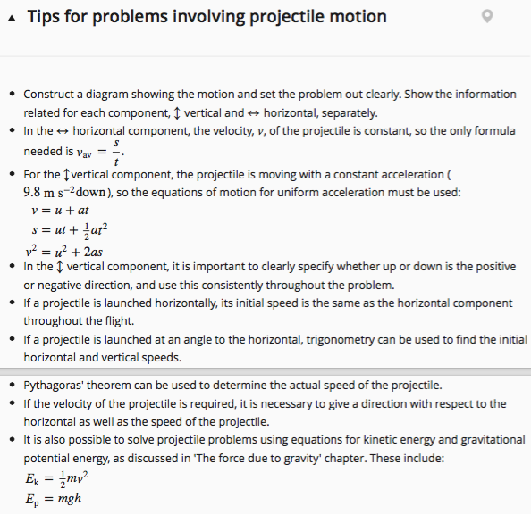

Examples

1. A stone is thrown horizontally off a cliff at 7.00 ms⁻¹. If the cliff is 1.22 x 10² m high,
calculate:

(a) the time taken to reach the ground.
(b) the distance from the base of the cliff the stone hits the ground.
(c) the impact velocity of the stone.

2. A volleyball player is 5.40 m from the net when she “digs” the ball 1.00 m from the ground,
causing it to rise to a height of 6.20 m above the court. Given that the opposition player on
the other side of the net is 2.60 m away from the net when she “sets” the ball, and the ball is
1.85 m above the ground, calculate:

(a) the vertical component of the initial velocity of the ball.
(b) the time of flight of the ball.
(c) the initial velocity of the ball after being struck.

3. Two boys are playing “catch” with a cricket ball. They are standing 35.0 m apart when one
throws the ball at an angle of 28.0° to the horizontal. At what speed must he throw the ball if
the other boy is to catch it at the same height as its release?

4.
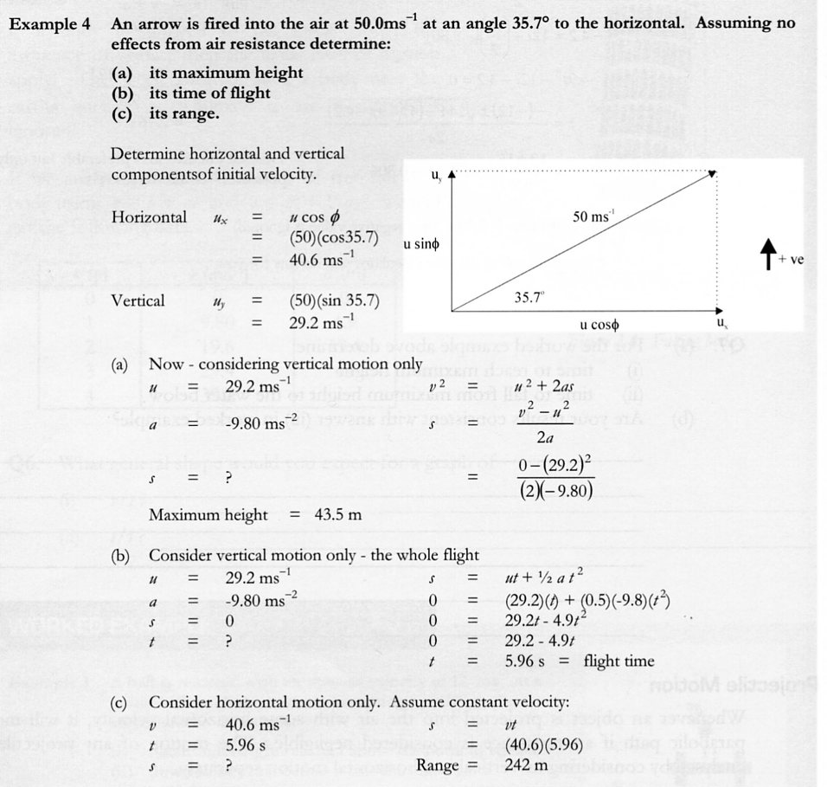

AIR RESISTANCE

Air resistance affect projectiles in a variety of ways.

The path of an object is not truly parabolic but is asymmetric with a gradual rise and a steeper descent.

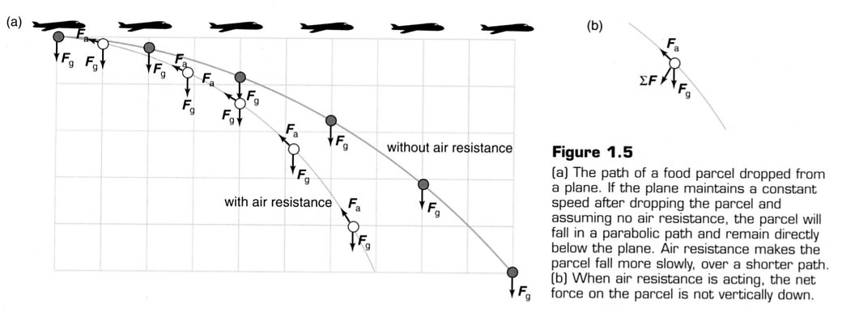

Objects that fall vertically through the atmosphere will ultimately reach a constant speed called terminal velocity.

At this speed, the force due to gravity is equalled by the frictional forces acting upwards, resulting in no nett force. Hence there is no nett acceleration and the object moves at constant velocity.

For most objects, this velocity is about 195 kmh⁻¹.

The actual size of the terminal velocity is determined by several factors.

1. Silhouette area - the area exposed to the air as the object falls.

A large area will mean a large force of friction.

e.g. Skydivers will open out their arms and legs to increase their silhouette area. This
allows them to control their movements in the air and they will have a lower
terminal velocity.

Javelins, racing cars, etc are streamlined (giving a small silhouette) and have
much smaller air resistance.

2. Silhouette area to mass ratio.

If this ratio is small, then the terminal velocity will be high.

e.g. A shot put has a large mass but small silhouette, so the ratio is small.
Hence air resistance has little effect.

A table tennis ball is very light so its ratio is much higher than the shot. Hence it
has a smaller terminal velocity and is severely affected by air resistance.

3. Spin - causes objects to change direction in the air.

e.g. Balls that spin (tennis, cricket, table tennis, golf, etc) have pressure differences
generated on opposite sides of them. As the high air pressure moves towards the
low pressure, it moves the ball.

CIRCULAR MOTION

An object moving in a circle at constant speed is always changing the direction of its instantaneous velocity. Thus it must be accelerating.

The direction of this acceleration is always towards the centre of the circle.

This can be shown as follows.

Calculation of Δv for the object moving around the circle is made by adding the vectors -u and v together since:
Δv = v-u

The complete derivation is of no concern here, but it is sufficient to say that the direction of Δv is towards the centre of the circle.

Given that , then the acceleration must also be towards the centre of the circle.

From F = ma, there must be a force in the direction of the nett acceleration. (This comes from Newton’s Second Law.)

This force is called a centripetal force.

The centripetal force is required to keep the object moving in a circle and can be provided by a string (or something similar) attached to the object, or gravity in other situations. All of these will be covered in notes.

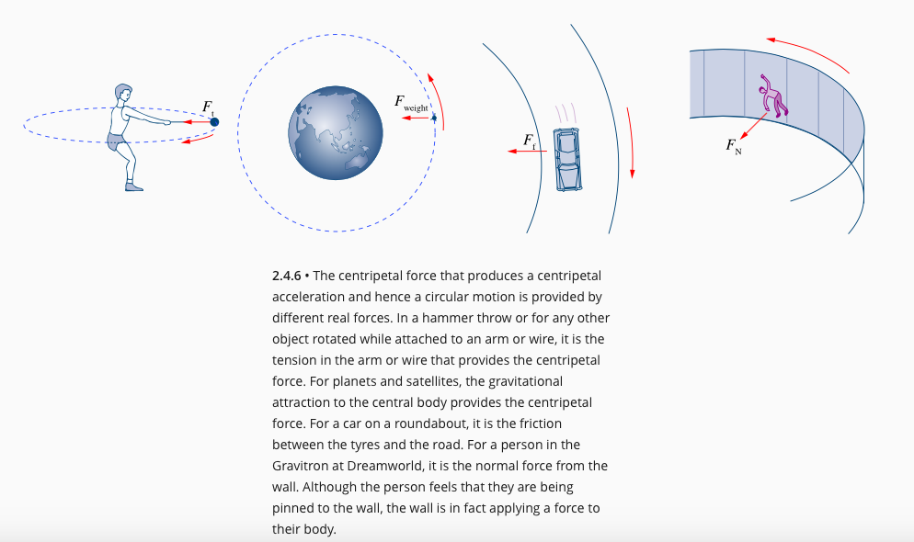
The centripetal force is given by:

where F_{c} = the centripetal force (N)
m = the mass of the object (kg)
v = orbital speed of the object (ms⁻¹)
r = the radius of the orbit (m).

The centripetal acceleration on an object is given by:

where a_{c} = centripetal acceleration (ms⁻²).

The orbital speed of an object is calculated using:

where T = the period of revolution (or the time taken for one
complete revolution) (s).

Examples

1.

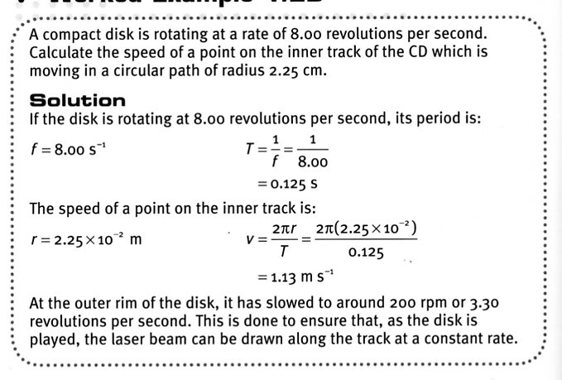

2.

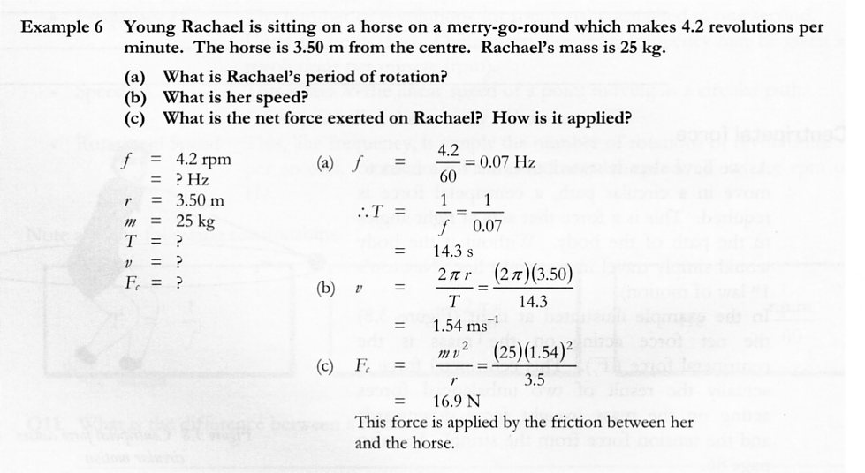

3. The Earth maintains an approximately circular path around the Sun. The average radius of
this orbit is 1.49 x 10⁸ km and the period is 365.26 days. The Earth’s mass is 5.98 x 10²⁴ kg.

What is the average gravitational force of the Sun on the Earth required to maintain this orbit?

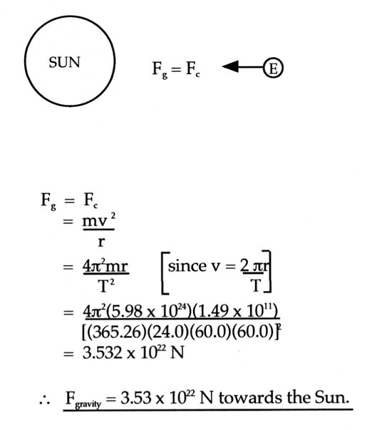

MOTION IN A VERTICAL CIRCLE

In solving problems involving vertical circular motion, always remember that:

“ΣF is always in the direction of the nett acceleration, which for circular motion is always
towards the centre of the circle”.

Use this information to draw clear diagrams to show the forces acting in the situation.

Objects Attached To A String

Note

From last year’s work on Newton’s Third Law:

Applying this to the situation at the bottom of the circle:

T is in the direction of the nett acceleration (i.e. towards the centre of the circle).
F_{w} is in the opposite direction to the nett acceleration.
∴ ΔF = T - F_{w}

Important

Don’t try to learn the above “equations” rotely.

Learn how to draw the diagram and apply Newton’s Third Law to derive them. Then you will be able to handle any question or problem presented to you!
Example 1

In an experiment to determine the force required to break a light string, a group of students analysed the motion of a small 30.0 g mass attached to a 75.0 cm piece of the string being whilst being whirled in a vertical circle. One student increased the speed of the mass in the circle until it caused the string to break. The students used a high-speed video to determine that the speed at the breaking point was
13.6 ms⁻¹.

(a) At which point in the circle would the string most likely have broken? Explain why.

(b) What is the force required to break the string?

Example 2

A student whirled a bucket of water above her head at a speed that just allowed the water to stay in the bucket as it passed overhead.

(a) Explain how it is possible to have the water stay in the bucket.
(b) Given the distance from the student’s shoulder to the centre of mass of the bucket and water
is 1.10 m, calculate the minimum speed required to keep the water in the bucket.

Example 3 (Conservation Of Mechanical Energy)

A roller coaster of mass 2.25 x 10³ kg is moving at 8.00 ms⁻¹ at point A in the diagram below.

(a) Calculate the total energy of the roller coaster at point A.
(b) Determine whether the coaster is able to safely make it through point B.
(c) If it does make it through B, calculate the force exerted by the track onto the roller coaster.

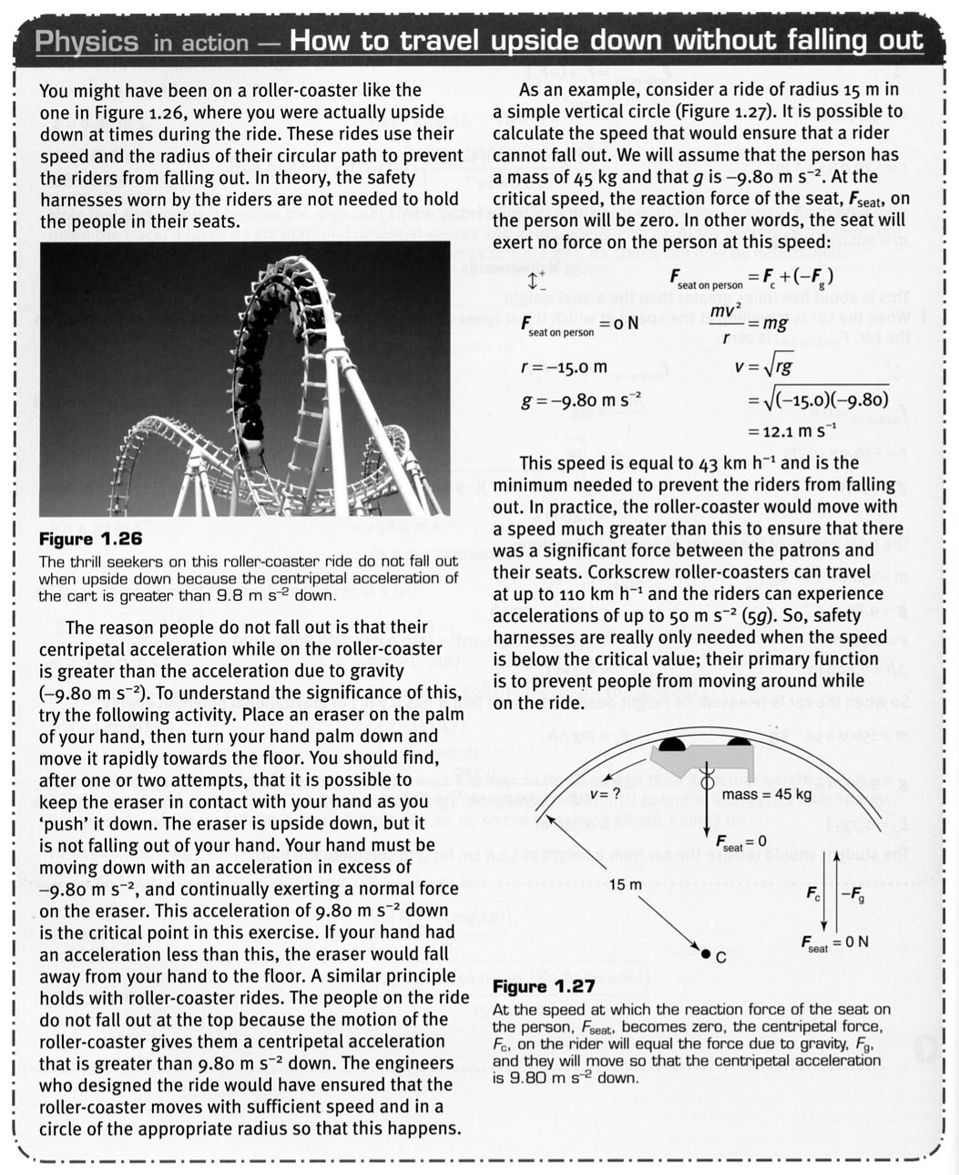

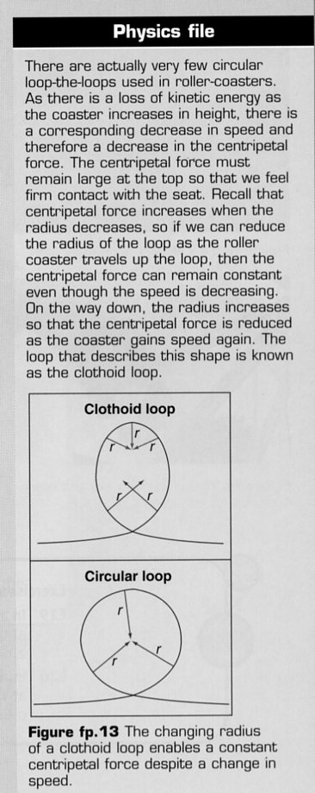

MOVING AROUND A CIRCULAR CURVE

Flat Curve

Consider a person running around a bend on an athletics track.

As seen in earlier notes, any object that moves around a horizontal curve must experience a centripetal force that is directed towards the centre of the curve.

If the person tries to run around the curve and remain perfectly upright, this centripetal force is supplied only by the friction between her shoe and the ground.

The person will actually lean into the curve, making it easier to move around the curve.

By doing this, the horizontal component of the reaction force experienced by the person from the ground will be able to provide the centripetal force required.

(The force due to friction is much less than this value and is considered insignificant.)
For calculations:

where φ = the angle between R and R_{h}.

Banked Curves

In order for cars and trains to successfully negotiate corners at certain speeds, the road or track is banked at a particular angle.

This allows for the reaction force from the ground to exert a horizontal component that provides the centripetal force, thus reducing the reliance on friction alone.

Consider a cyclist riding around a velodrome with the angle of banking = θ.

If the frictional forces are considered negligible, then the following applies.

Note

This formula applies to all “banking” situations.

e.g. A plane or bird banking in flight.

A Frisbee or discus banking in flight.

The banking used on corners for roads and railways.

Try to remember how it is derived rather than rotely remembering it!

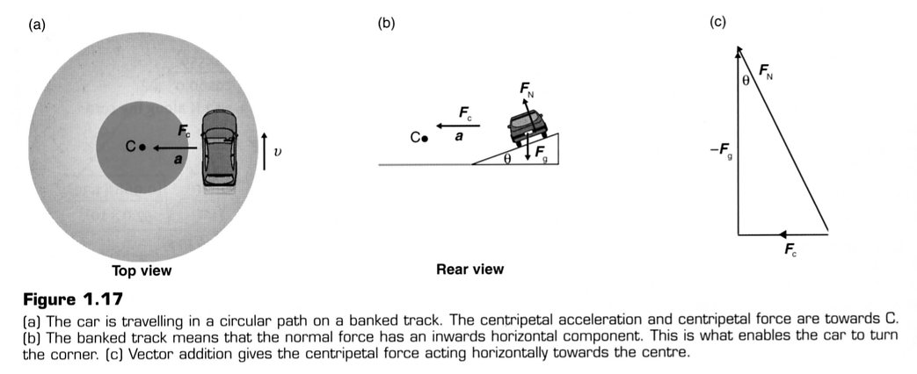

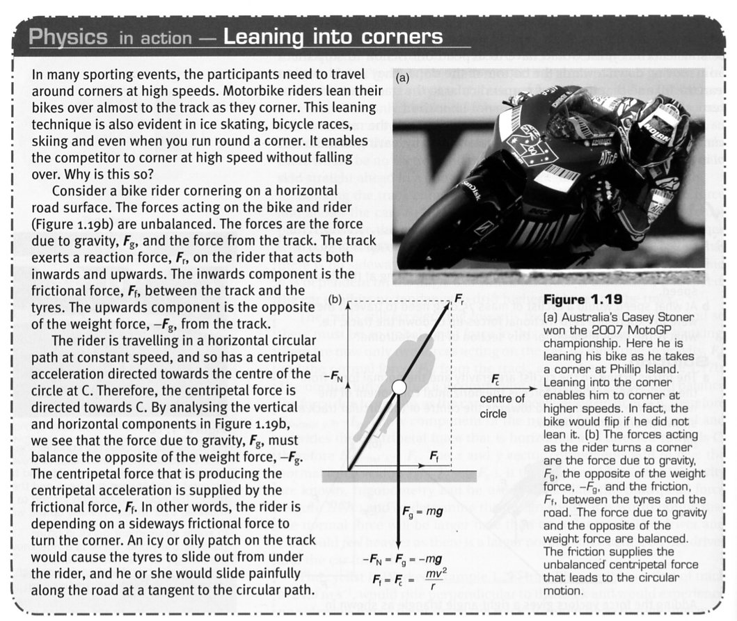
Examples

1. Westrail engineers have designed a curve on the rail line out to Kalgoorlie to allow the
Prospector train to safely negotiate it at 90.0 kmh⁻¹. What must be the radius of the curve if
the angle of the banking is 5.25°?

2.
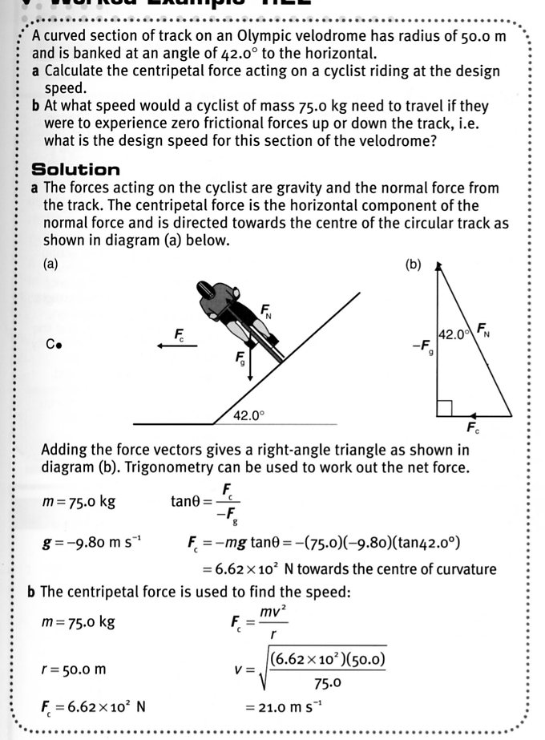

3. Conical Pendulum

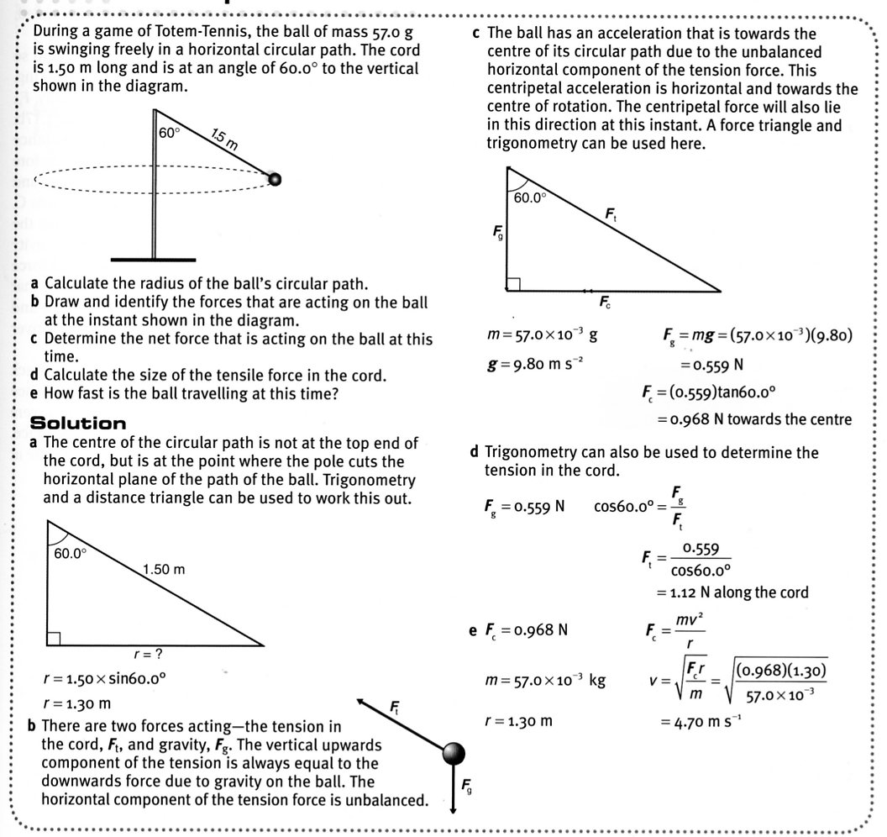

LAW OF UNIVERSAL GRAVITATION

Newton formulated this law as:

“The force between any two masses separated by a distance is an attractive force acting
along the line joining the centre of the two masses.”

The gravitational force acting between two bodies, m₁ and m₂:

• is one of attraction, and can be considered to act from the centre of each mass.
• acts equally and oppositely on each mass (Newton’s third law): F₁ = -|F₂.
• is weaker if the masses are further apart. Gravitation acts in an inverse
square manner.
i.e. where r is the distance in metres between the centres of the masses.
• depends directly on the mass of each body involved
i.e. and .

Newton showed that the force acts as if the mass of each body is located at its centre of mass. This is why the distance of separation r must be measured from the centre of each object.

This is expressed as:
where F = the gravitational force (N)
G = universal gravitational constant
= 6.67 x 10⁻¹¹ Nm²kg⁻²
m₁ , m₂ = the two masses (kg)
d = distance between the centre of masses (m)

Note

The centre of mass of an object is the point at which all the object’s mass seems to act.

For a regular shaped object, the centre of mass is in the geometric centre.

e.g. a rectangular box.

For irregular objects such as boomerangs, the centre of mass is outside the body.
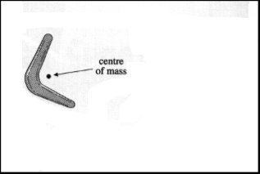
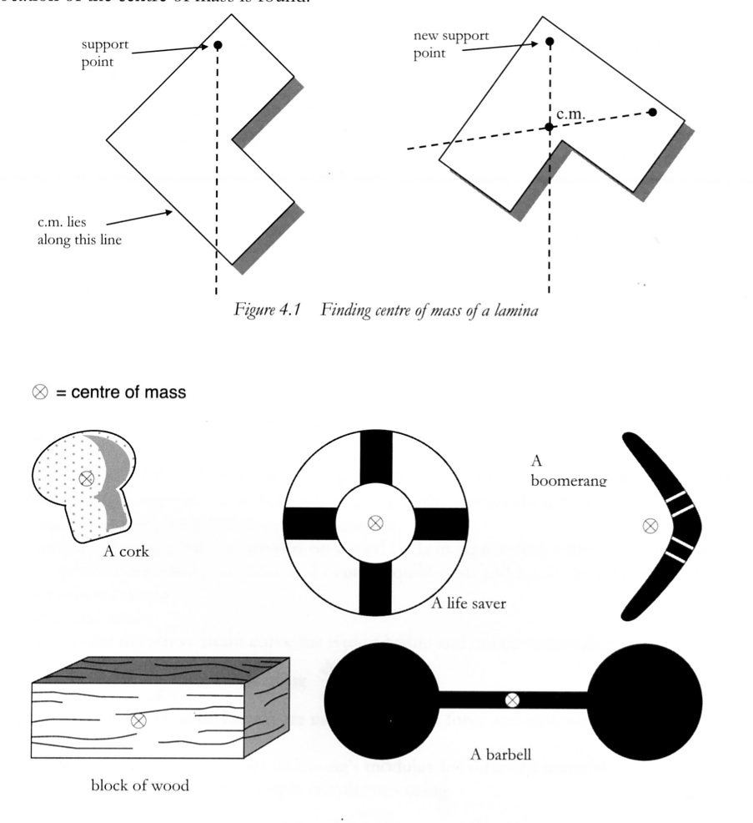

The simplest method to find the centre of mass of an object is to suspend it from two different points.

The point where two imaginary lines (showing the direction of the force due to gravity) cross, that is the centre of mass.

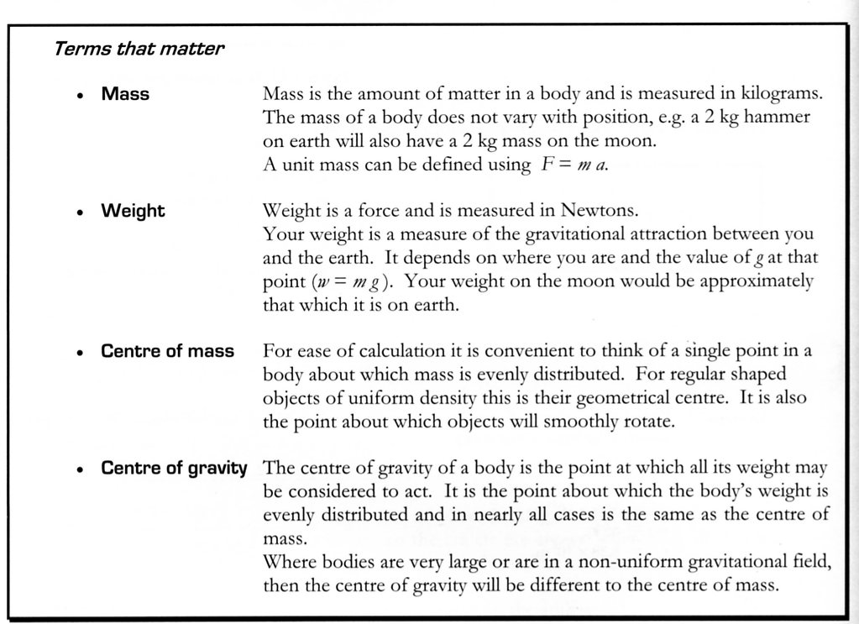

Example 1

The electron in a hydrogen atom is on average 5.29 x 10⁻¹¹ m from the proton. Given that the mass of the electron is 9.11 x 10⁻³¹ kg and that of a proton is 1.67 x 10⁻²⁷ kg, calculate the gravitational force between them.

Note The force due to gravity is insignificant when compared with the force due to the
electrostatic attraction between the opposite charges.

Example 2

The Moon orbits about the centre of the Earth at a distance of 3.84 x 10⁵ km. Where is the theoretical point between these two bodies where an object would experience no nett force of attraction due to them?
(m_{Moon} =7.22 x 10²² kg, m_{Earth} = 5.98 x 10²⁴ kg)

The gravitational field strength, or acceleration due to gravity, around an object is given by:

where g = acceleration due to gravity (ms⁻²)
m = the mass of the object (kg)
d = distance from the centre of mass of the object (m)

From this equation it follows that for a mass some height above the Earth’s surface, the acceleration due to gravity is given by:

where m_{E} = the mass of the Earth (kg)
d = the distance from the centre of the Earth (m)
= r_{E} + h (radius of Earth + height above ground)

Note

This formula can apply to any object at any height above any heavenly body such as the Moon, Jupiter, Mars, etc.

For a mass at the Earth’s surface, the acceleration due to gravity is given by:

where r_{E} = the radius of the Earth (m)

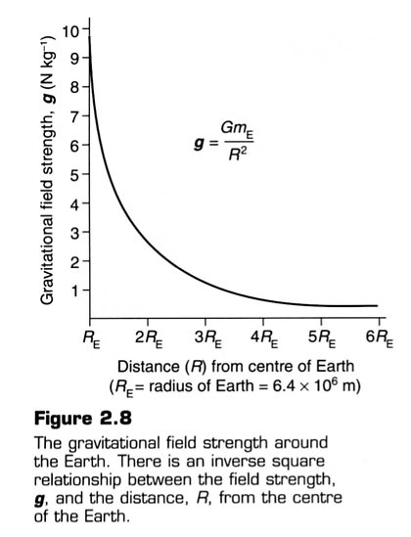

Note

This equation can apply to all heavenly bodies as well.

e.g. Mars, Jupiter, the Moon, etc.

Example 1

The space shuttle orbits the Earth in a circular orbit at 1.10 x 10² km above the surface. Calculate the acceleration due to gravity at this height.

Example 2

What is the acceleration on the Moon’s surface, given its mass is 7.22 x 10²² kg and its radius is
1.74 x 10⁶ m?

Example 3

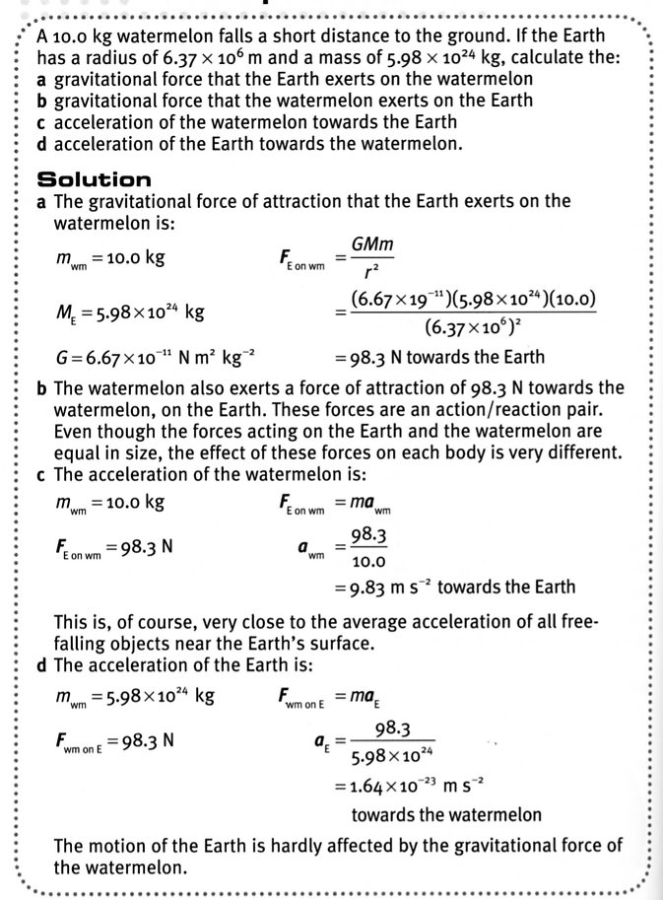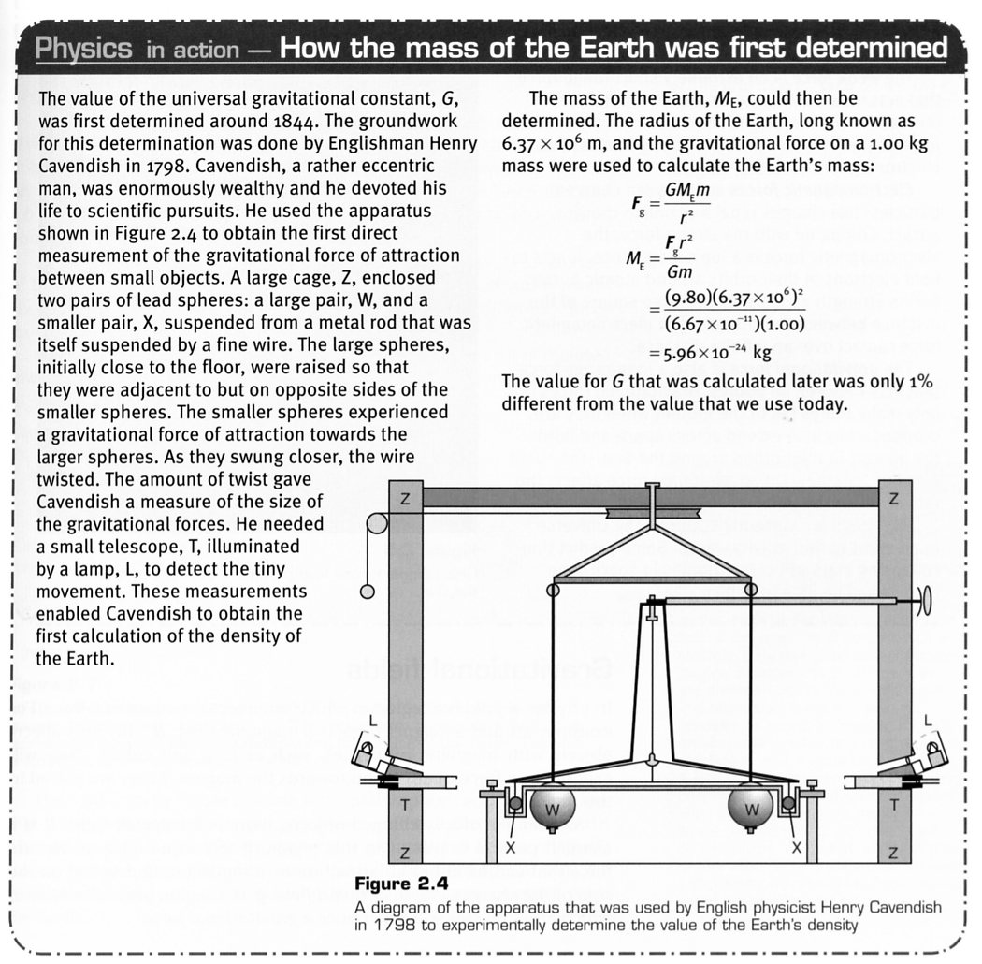

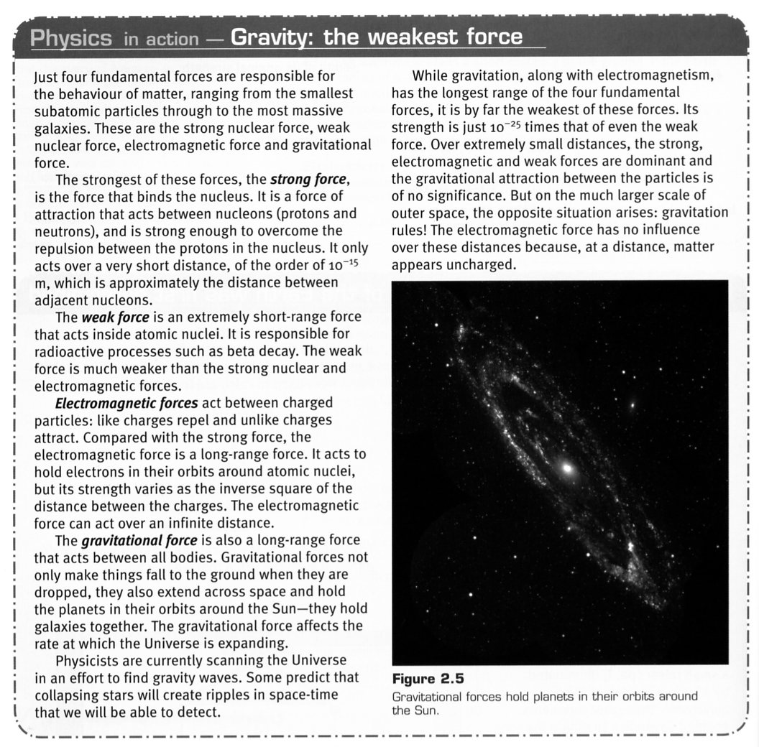

Representing Gravitational Fields

A gravitational field, g, can be represented diagrammatically by lines with arrows that show the direction of the force on the object.

The gravitational field around the Earth is directed towards the centre of the Earth and is not uniform. It becomes weaker at higher altitudes.

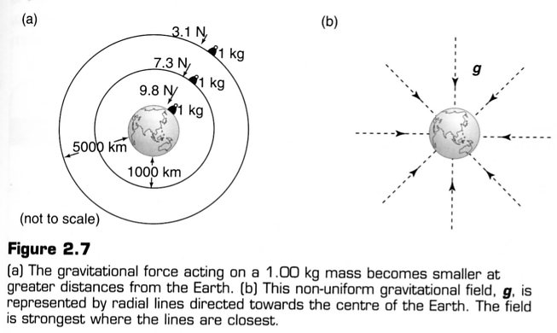

Motion Of Satellites

A satellite is any body that orbits about a larger (more massive) object in space.
e.g. The Moon about the Earth, the planets about the Sun, etc.

When a satellite is orbiting the Earth, a centripetal force is needed to maintain its circular orbit while a horizontal speed is required to keep it in the orbit.
The satellite is constantly accelerated by gravity towards the centre of the Earth while the horizontal speed maintains the orbit.

i.e. A gravitational force provides the centripetal force.

where r = the radius of the orbit (m)
= r_{Earth} + h (height above the surface)

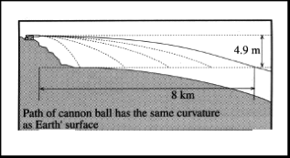
Consider the firing of a shell from a cannon horizontally from a height of 1.00 m above the ground.

It initially has no vertical motion, only a large horizontal velocity. It will immediately start to fall to the ground under the influence of gravity and will hit the ground.

The faster the shell is fired, the further it will travel horizontally before it hits the ground.

If the speed of the shell is increased to about 8.00 kms⁻¹, it will actually follow the curve of the Earth rather than hitting it.

i.e. It appears to be “falling around the Earth”.

Hence it has begun to orbit the Earth (although in the atmosphere friction would soon cause it to slow and fall to the ground).
Example 1

The Aussat satellites that provide television and communications for Australia are located in “geostationary” orbits - an orbit that keeps them over the same point on the Earth. They are located above the equator to the north of Australia.

(a) Why must geostationary satellites be located above the equator and at no other latitude?
(b) At which height above the Earth would these satellites be found?

(a) Satellites must orbit west to east in a period of 24 hours to be above the same point on the
Earth’s surface.

Satellites must also orbit about the centre of mass of the Earth.

All of these conditions can only be met if the satellite is located directly above the equator.

Example 2

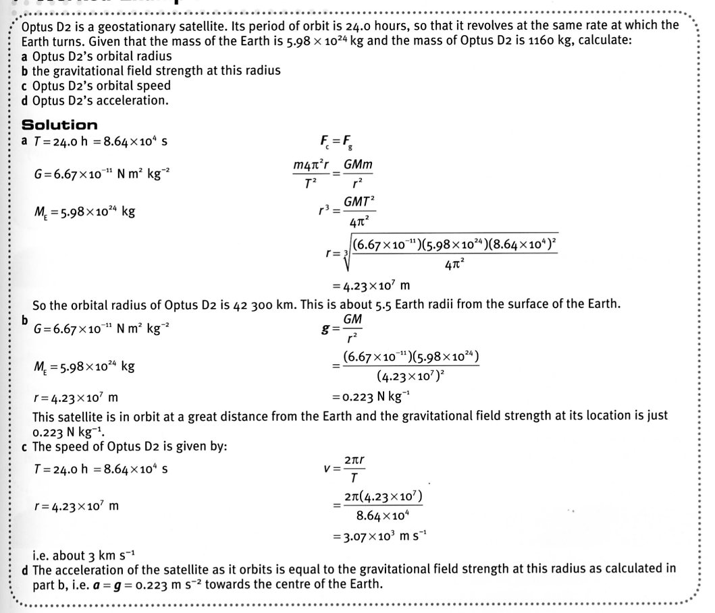

Example 3

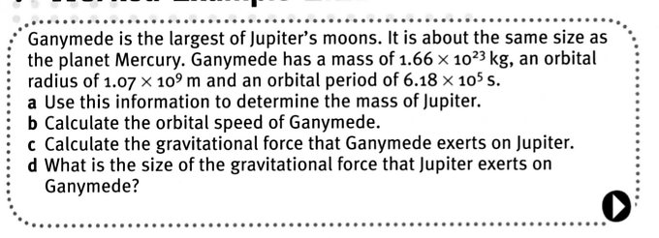

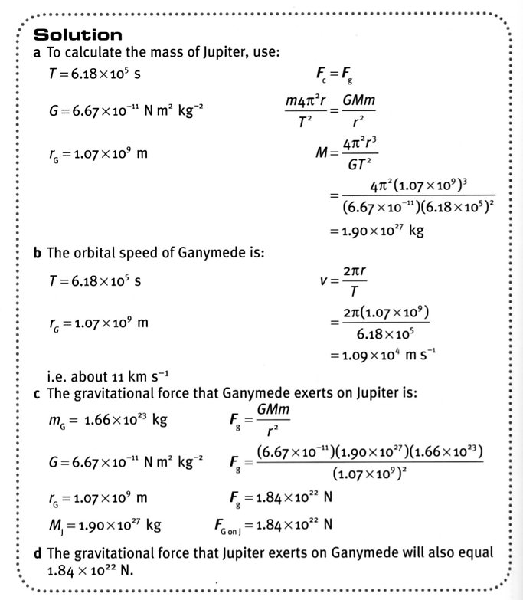

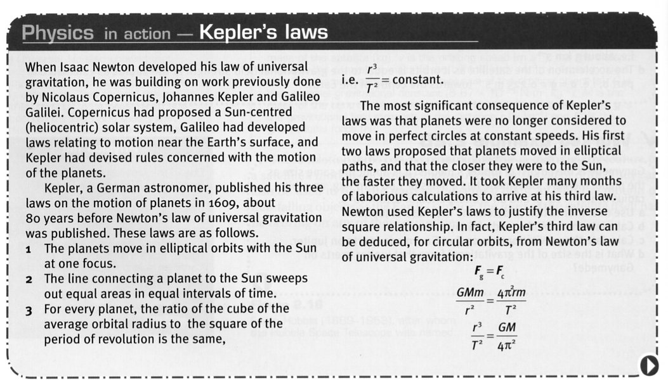

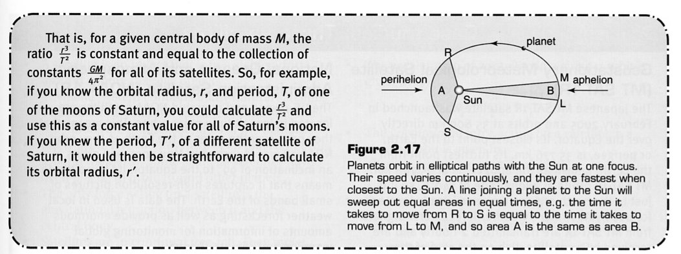

Launching Satellites

Most satellites are launched near the equator.

Here the surface of the Earth has a spin speed of 1640 kmh⁻¹ (464 ms⁻¹) which scientists use in order to give the satellites a horizontal speed. It significantly adds to the required speed of
8.00 x 10³ ms⁻¹ for a stable orbit.

Satellites And Their Energy

Consider satellites such as comets that move in elliptical orbits. In fact most satellites that orbit the Earth have elliptical paths.

Such orbits mean that the satellite will vary its distance from the planet or Sun, resulting in different forces of gravitational attraction and hence orbital speeds.

Since such satellites neither gain nor lose energy (they aren’t powered by rockets which add energy), decreasing the distance to the planet will decrease the E_{p} but increase the E_{k} (orbital speed).

i.e. E_{total} = E_{p} + E_{k}

If the energy of a satellite is changed, it will move to a higher or lower orbit depending on whether energy is added or removed.

e.g. Speeding a satellite up will increase its E_{k}, causing it to move to a higher orbit. As it
does so, it will slow down to be stable in the new orbit. Thus the added energy will be
seen as an increase in the E_{p}.

Slowing the satellite will remove energy from it. It will settle into a lower orbit where
it will speed up. The change in energy is seen as a decrease in E_{p} but an increase in E_{k}.

Satellites that “decay” in orbit will lose energy, settle into the atmosphere and speed
up, causing them to burn up due to the friction.

